**Ahsanullah University of Science and Technology**



Department of Computer Science and Engineering

Program: Bachelor of Science in Computer Science and Engineering

Course No: CSE 4108

Course Title: Artificial Intelligence Lab

Assignment no: 02

Date of Submission: 27.06.2022

Submitted to:

Mr. Md. Siam Ansary

Lecturer, Department of CSE, AUST.

Ms. Tamanna Tabassum

Lecturer, Department of CSE, AUST.

Submitted By,

Name: S. M. Tasnimul Hasan

Student ID: 18.02.04.142

**Question 1**: For 8 Queens problem, heuristic can be calculated as the number of attacking pairs. Hence, heuristic, h = face to face in the row + face to face diagonally up + face to face diagonally down. Write a Python program for finding out this heuristic.

**Solution:**

**Python Code:**

queenPos = [[0,0,0,0,0,0,1,0],  
 [0,0,0,1,0,0,0,0],  
 [1,0,0,0,0,0,0,0],  
 [0,0,1,0,0,0,0,0],  
 [0,0,0,0,1,0,0,0],  
 [0,0,0,0,0,1,0,0],  
 [0,0,0,0,0,0,0,0],  
 [0,1,0,0,0,0,0,1]]  
  
row, col = 8, 8  
  
**def** rowAttack(queenPos):  
 count = 0  
 attacking_pair = 0  
 **for** i **in** range(8):  
 **for** j **in** range(8):  
 **if**(queenPos[i][j] == 1):  
 count = count + 1  
 **if** (count > 1):  
 attacking_pair = attacking_pair + ((count*(count-1))/2)  
 count = 0  
 **return** attacking_pair  
  
**def** diagonallyUp(queenPos):  
 attacking_pair = 0  
 **for** k **in** range(0, 8):  
 i=7  
 j=k  
 count=0  
 **for** l **in** range(0, k+1):  
 **if**(queenPos[i][j] == 1):  
 count = count + 1  
 j=j-1  
 i=i-1  
 **if** (count > 1):  
 attacking_pair = attacking_pair + ((count*(count-1))/2)  
  
 **for** k **in** range(0, 7):  
 i=k  
 j=7  
 count=0  
 **for** l **in** range(0, k+1):  
 **if**(queenPos[i][j] == 1):  
 count = count + 1  
 j=j-1  
 i=i-1  
 **if** (count > 1):  
 attacking_pair = attacking_pair + ((count*(count-1))/2)  
 **return** attacking_pair  
  
**def** diagonallyDown(queenPos):  
 attacking_pair = 0  
 **for** i **in** range(1, (row+col)):  
 start_col = max(0, i-row)  
 temp = min(i, (col-start_col), row)  
 count = 0  
 **for** j **in** range(0, temp):  
 **if**(queenPos[min(row, i) - j -1][start_col+j] == 1):  
 count = count + 1  
 **if** (count > 1):  
 attacking_pair = ((count*(count-1))/2)  
 **return** attacking_pair  
  
total = rowAttack(queenPos) + diagonallyUp(queenPos) + diagonallyDown(queenPos)  
print(**'Total Number of Attacking pairs: '** ,total)

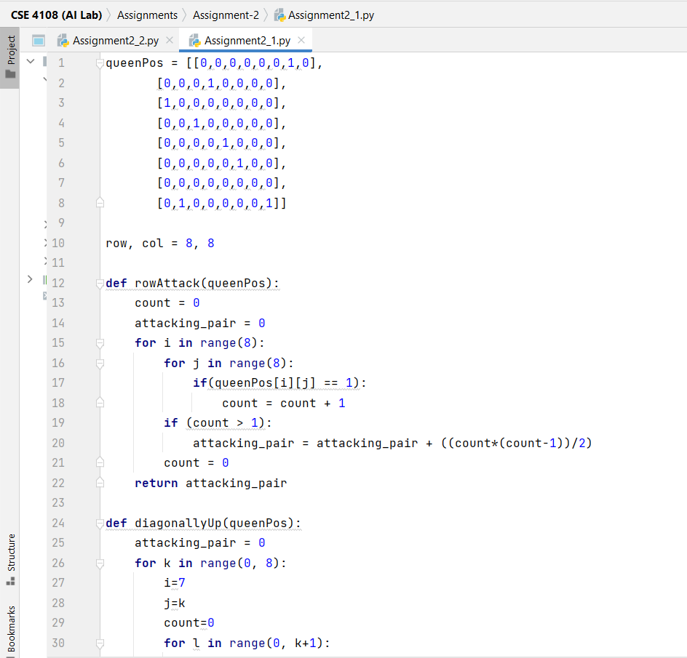

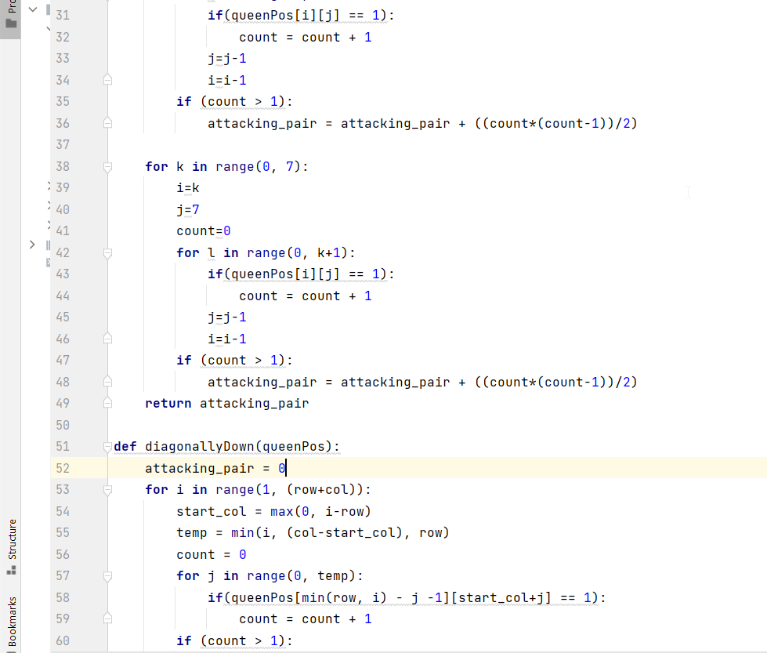

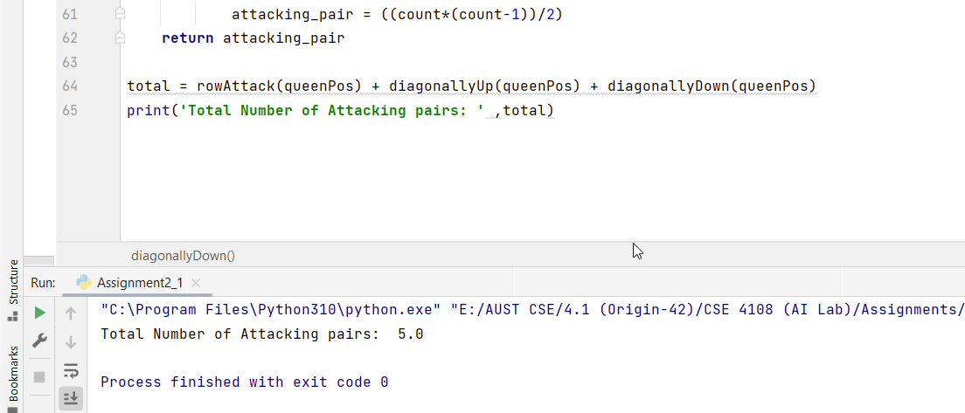

**Question 2**: Write a Python program where the heuristic of 8 puzzle problem is calculated as the Manhattan distances of the tiles.

**Solution:**

**Python Code:**

gtp = [(1, 1, 1), (2, 1, 2), (3, 1, 3), (4, 2, 3), (5, 3, 3), (6, 3, 2), (7, 3, 1), (8, 2, 1)]  
gblnk = (2, 2)  
  
tp = [(1, 1, 2), (2, 1, 3), (3, 2, 1), (4, 2, 3), (5, 3, 3), (6, 2, 2), (7, 3, 2), (8, 1, 1)]  
blnk = (3, 1)  
list1 = []  
  
i = 0  
h = 0  
**for** i **in** range(8):  
 **if** ((gtp[i][1] != tp[i][1]) **or** (gtp[i][2] != tp[i][2])):  
 list1.append(abs(gtp[i][1] - tp[i][1]) + abs(gtp[i][2] - tp[i][2]))  
  
**for** i **in** list1:  
 h = h + i  
print(**"Manhattan Distance:"**, h)

